

Project Report for
CE4041 – Artificial Intelligence

Classifier implementation for the MNIST hand written digits database

Project Team

Student Name | Student Id
Qinyuan | 20137095
Eamon Moloney | 8457077
Ibrahim Saana Aminu | 25381993
Des Powell | 9513833
Terence Coffey | 15223124

Contents
Project Team 2
Introduction 4
Approach 4
Investigate Solution Space 4
Training, Validation and Test data 5
Choosing the models for Initial Evaluation 5
Convolute Neural Network 7
CNN Layer review 7
Early Stopping 9
Selection and Tuning Keras function parameters 9
Test Application Overview 11
Results 12
Accuracy - Overfitting Discussion 13
Deliverables 14
Lessons learned and changes for future Projects 14
Conclusion 14
References 15
Appendix A 16

Introduction
This project creates a Classifier for the Modified National Institute of Standards and Technology (MNIST) handwritten digits database using the Keras Neural Network library and coding in Python. The classifier achieves a testing accuracy of at least 99 percent. The MNIST 1] dataset contains 60,000 28 x 28 grey scale images of handwritten digits and their associated labels for training and 10,000 images for test. The classifier is a 10-way classifier with 10 possible digits(0-9) and 10 possible digit classes. The MNIST dataset is prebuilt into the Keras dataset.

Approach
Team Work:
An in-person meeting was used as the basis for deciding on the understanding of the project requirements and the approach to adopt in the code implementations. Based on these meetings, the group unanimously adopted Google colab notebook to allow for effective collaboration with input at various levels by the team members. The final code were run centrally on one group member’s computer with each member also running the codes individually to scan for error and necessary adjustments where necessary. The final project report was created, shared and edited by all team members via OneDrive. The content of the final submission was agreed upon by all members.

Investigate Solution Space
After taking guidance from Colin and from our week 5 course notes, we started to investigate some options using this information. We realised that there was potentially many ways of achieving a test accuracy performance level of 99 percent. The entry in Wikipedia [1] for mnist digits database provides a table which showed the error rate for different types of Neural Networks. The range of possible solutions included Convoluted Neural Networks(CNNs) , K-Nearest Neighbours, Linear and non-linear classifiers. We decided to limit our choices to CNNs as this was related to our course and lecture material. Generative AI such as Gemini and ChatGP allowed us to quickly create prototype CNNs using the Keras package to see if we could get a test accuracy of 99 percent.
Initial testing using Google Colabs for one test case for each model indicated that it would take approximately 15 minutes per model to run one test with a very limited set of test parameters. The same test, if performed on a laptop took about 6 minutes. There is more about this later in the report. The test accuracy reported in Fig 2 was produced using Google Colabs and is consistent with the results generated using the test environment on the HP test laptop.

Training, Validation and Test data
The Keras dataset provides training and test data. The mnist.load() function loads the training and test data and their labels. The training data is futher subdivided to provide a validation portion. When the fit() function is called to train the model, a validation split of 0.2 or 20% of the training data is used exclusively validation. The training data is also shuffled during the process as the fit() function has been request to perform this functionality. See Fig 1 The test data is only used after training and validation phases have been completed.
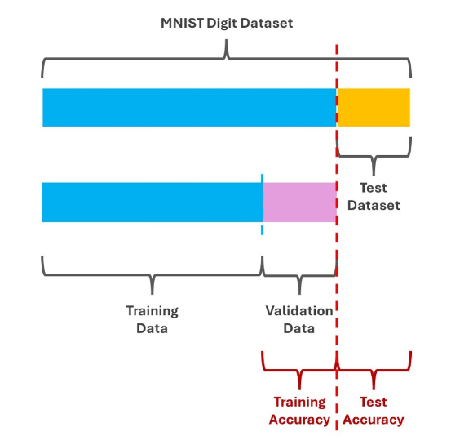
Fig 1 Shows the relationship between training, validation and test data.

Choosing the models for Initial Evaluation
The model we selected for evaluation was the Sequential model. This means that the model uses a Linear stack of layers where the output of one layer becomes the input for the next layer.
Initial test results with a one Convolve 2D layer typically produced an accuracy test result at or below 98 percent. Only models which consistently produced accuracy results above 99 percent were considered for the next stage.
Models with 2 Convolve 2D layers consistently produced an accuracy test result above 99 per cent. These produced accuracy test result in the range 0.9905 to 0.992 and therefore were seen as good candidates for further evaluations/testing. These initial evaluations were run 3 times to ensure that they reliably produces results above 99 percent. The 3 models are compared in Fig 2 and Fig 3.
Keras Layer | Model 1 | Model 2 | Model 3
Input | Yes | Yes | Yes
Conv2D | Yes | Yes | Yes
MaxPooling2D | Yes | Yes | Yes
Dropout | No | Yes | No
Conv2D | Yes | Yes | Yes
MaxPool2D | Yes | Yes | Yes
Dropout | No | Yes | No
Flatten | Yes | Yes | Yes
Dropout | Yes | No | Yes
Dense | No | Yes | Yes
Dropout | No | No | Yes
Dense(Output) | Yes | Yes | Yes
Test Accuracy | 0.99140000 | 0.99070000 | 0.99210000
Fig. 2 Shows the corresponding layers used in the 3 candidate models

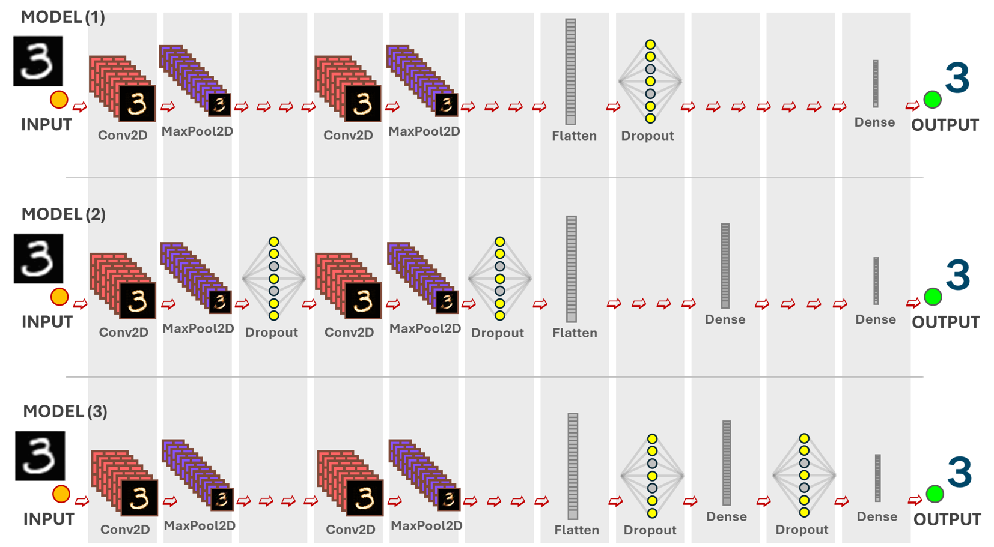
Fig 3. Diagram showing the layer distribution in the 3 selected initial sequential models

Convolute Neural Network
A high level description of the delivered Python code solution is described. The application imports the tensorflow.Keras library. The application is structures as follows
1) Reads the training and test data from the Keras dataset,
- Set the parameters to the values that was identified in the best performing CNN model.
- Create the CNN sequential model. This adds multiple specialised layers to a sequential model or defines a model with the layers defined as part of the sequential model. The later approach is what we used. See Layer review for more details.
- Compile and train the model. The loss method selected is categorical_crossentropy. A validation parameter tells the fit() method to reserve 20 percent of the test data for validation. The shuffle parameter is set to true so it will also be shuffled. Early Stopping was also passed as a paramter to the fit method. See Early Stopping for more detail.
- Evaluate the test model using the test data
- Display metrics such as test accuracy, training accuracy and loss precision
- If number of runs is not equal to three then complete steps 1 to 7
A separate application( explore_vX.ipynb Juypter notebook) was written which is the same as this except it had multiple experiment values in parameter lists. This application has only one value in each parameter list corresponding to the experiment which was the highest performing model.

CNN Layer review
In this section , we provide a description of what happens in each layer of the sequential model to help our understanding of the model. The Keras library function which provides this functionality is also introduced. The relevant Keras function(shown in bold face) is shown as the first part of each description.
layers.Input (shape=(28, 28, 1) This is the input layer. It defines a grey scale (1) input object ,28 by 28 pixels in size representing our input image. The image is a two dimensional representation of the image. The input layer takes the whole image as input. The convolution 2d layers in the model can subsequently work on different parts/features of the image.

layers.Conv2D(64, kernel_size=(3, 3), activation='relu'), defines a Convolution layer which is important for processing images in a Convolutional Neural Network(CNN). Each filter learns to detect different patterns in the input image. Additional filters can identify more complex features but computational costs also increase. The kernel size means that the filter will examine a 3x3 pixel region of the image at a time. The activation function will apply Rectified Linear Unit(ReLU) function after the convolution operation. This introduces non linearity into the model. It replaces negative values with zero and helps the model to learn more complex patterns. Convolution layers are important as they are excellent at automatically learning and extracting relevant features from images. They maintain the spatial relationship thereby making them suitable for image recognition tasks. If you stack multiple convolutiona layers, CNNs can learn increasingly complex features. This can vary from edges and texture in early layers to more abstract object parts in later layers.

layers.MaxPooling2D(pool_size=(2, 2)) is used for down sampling feature maps. Max pooling is a downsampling technique that reduces the size of feature maps, making the model more efficient and robust while preserving important features. It's a key component in many successful CNN architectures. Your feature map is a grid of numbers. Max pooling uses a small 2 x 2 window called a sliding window. This sliding window slides over the feature map without overlapping. For each window position, it selects the maximum value within that window and discards the rest. This creates a new, smaller grid where each value represents the maximum value from the corresponding region in the fature map. This reduces the size of the feature map but makes it more efficient and robust while preserving important features.

layers.Dropout(0.25) This defines a Droupout layer which is a regularisation technique used to prevent overfitting and improves generalisation. The dropout rate controls the probability of a neuron being dropped and is passed as an argument to the Dropout layer. This layer works by randomly deactivating neurons during training. This forces the network to learn more robust features. It does this by selecting a subset of neurons in the training step and setting their output to 0. The model then performs forward and backward passes with the active neutrons. The weights of the networks are updated based on the error calculated with the dropped out neurons. This process is then repeated for each training step, with a different set of neurons being dropped out each time.

layers.Flatten() Flattening is necessary to bridge the gap between convolutional/pooling layers and dense layers(Fully connected layers) in CNNs. This layer converts multidimensional output from convolution and pooling layers into a 1 D vector that can be used by dense layers for classification. e.g If the output from the previous layer is a 3D tensor with shape (10, 10 ,32) (e.g. 32 features maps of size 10 x 10), the flattening layer will transform it into a 1D array of size 3200(10 x 10 x 32) Dense layers expect their input to be a 1D vector. By flattening the output of previous layers, it combines all the learned features into a single vector.

layers.Dense(10, activation='softmax') This defines the output layer in the model. Since it is predicting the digits 0 to 9, there will be 10 outputs. Dense means that each unit in this layer is connected to every unit in the previous layer. Softmax calculates the probability that the input digit image belongs to each of the ten output digits. This layer can be thought of as a decision making part of the model as it classify the input image into one of 10 digit categories based on the probabilities. The highest probability corresponds to the model's predicted digit for the input image.

Early Stopping
“This is useful to stop training when some parameter (typically validation loss) starts to increase while training loss is continuing to decrease. This is usually a sign of overfitting on the model.
EarlyStopping(monitor='val_loss' , #Validation lss monitoring
min-delta=0, ' Min allowed changes to be ignored
patience=2, # Wait for epochs after to stop
mode ='auto') #Halt if val_loss changes direction.
These details were passed to the fit function. More details about this later in the report.

Selection and Tuning Keras function parameters
The next phase in the exploratory phase was to tune the models to identify additional performance improvement by adjusting parameters in the main Keras function calls. One of our goals was to try to execute all the test models and test case containing all combinations of the relevant Keras function parameters within 8 hours. This would allow an hour or two in the case of test runs exceeding 8 hours. We also limited our model selection to 3 models due to this constraint.this work was done in explore_VX.ipynb Juypter notebook. The parameters include the following dropout_rate, batch_size, validation_split, learning_rate, kernel_size, filter_size, and regulariser. There was 48 tests per model.
It was decided to run all the tests on one laptop as the tests would be faster to complete and the risk of exceeding the amount of free computational resources on the Google cloud using Google Colab for a particular individual would be minimised. The laptop was a HP zbook and had the following specification
12th Gen Intel Core i7-1265U × 12 Processors,
Graphics NVIDIA Corporation / Mesa Intel® Graphics (ADL GT2 – but un used as library dependencies for the software below would have required the laptops device drivers to be down graded. It was considered to be too risky to do this.
The following software was also installed
Linux Ubuntu 20.04 Operating System,
VS Code 1.95.0, Python 3.12.4,
TensorFlow 2.18.0,
Keras 3.6.0 ,
Numpy 1.26.4,
Cuda,
cuDNN.

The parameters for Convolve 2D and the drop out layers were identified and a range of values for these were selected. Our intension was to determine if we could further improve the test accuracy by a particular combination of parameter settings. We had to limit our choice of possible function parameters and the range of values we could assign to them so as to keep the execution time to approximately 8 hours. e.g. We only tested with values of 0.2 and 0.5 for the Dropout layer. Maybe, 0.3 might have produced even better results.
The relevant Keras functions and their parameters which could contribute to an improvement in performance were identified as shown in Fig 4.
Items in Fig 3 that are high lighted in Blue, are additional parameters/values which have been added to the 3 sequential models.
Training– Validation/Test Data | Parameter | Range or values | Description
Training and Test data are available from MNIST using the mnist.load_data() function. | Training /Validation Split | 0.8/0.2 | The training and test data are provided in MNIST. The validaion_split parameter passed into the fit() function, determines the amount of the training set which will be reserved for validation.  In the fit() function, the shuffle parameter tells the training function wherher or not to peform shuffling on the training data.
Keras Function Name | Variables for model
Conv2D | filter_size | 15, 32, 64 | [2] It is used in feature extraction. It slides across the input image.It is the dimension of the output space.
 | kernel_size | 3,5 | Specifies the size of th convolution window
 | padding | 'same' | Padding is applied evenly to the left/right or up/down of the input.
 | kernel_initializer | HeNormal | Initialiser for the convolution kernel
 | Activation | 'relu' | Activation function
 | lernel_regularizer | Regularizers.l2() | Also in Dense layer. Regularization is a technique to help prevent overfitting.
Dense | filter | 15,32,64
 | activation | 'softmax'
 | lernel_regularizer | Regularizers.l2() | Also in Convolve2D Layer. It helps to prevent overfitting.
MaxPooling2D | pool_size |  | Factors by which to downscale dimension 1 and 2
Model.fit() | Batch size | 32, 64 | The batch_size specifies the number of training samples to be processed before the model's intermal parameters are updated
Dropout | dropout_rate | 0.2, 0.5 | Fraction of the input units to drop.
Model.compile | loss | “categorical_crossentropy” | This is a loss function . See description below for reason to use it.
 | optimizer | “adam”  learning_rate | This is a stochastic gradient decent method baed on adaptive estimation of first and second-order moments. The learning rate defaults to 0.001  0.0001, 0.01
Fig. 4 Keras Function calls and 'tuned' parameters

Test Application Overview
A Python test application (exploration_X.ipynb) was designed around the 3 identified sequential test models. The hard coded parameters were replaced with a list variable where appropriate and code was added so one of the 3 models could be selected from the model_id_list for each run. This code was then within a larger for loop which worked its way through the various combination of the model parameters, one model parameter at a time.
A final loop , controlled by NUM_RUNS determined the number of times you wanted these overall tests to run to ensure the reliabiility of the test accuracy result. Validate and test accuracy were written to standard out. A history object return by model.fit() stores the results which can be used to plot graphs and extract information by model and epoch. The name of this application is exploration_v2.0.ipynp It is a Juypter notebook which is available if requested. Only when we were sure that all combinations could be tested via this test program, we were then ready to run the tests and get the settings for the paramters and the model which generated the best test accuracy.

Finding the best model and parameter settings
After the testing application had finished running, The test results were sorted into descending order by test accuracy using a shell script. See Fig 5 ) and the parameters for the best performing model were noted for the next step. The top 16 results are shown in Appendix A.
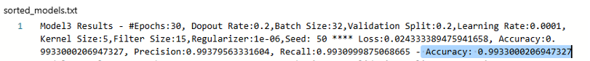
Fig 5 The top performing model with parameter setting and accuracy

Results
The results in Appendix A are summarised here. Model 3 is the best performing model with a test accuracy of 0.99330002. This occurred on Epoch 30. The details are as follows
Dopout Rate:0.2,Batch Size:32,Validation Split:0.2,Learning Rate:0.0001,Kernel Size:5,Filter Size:15,Regularizer:1e-06,Seed: 50 * Loss:0.024333389475941658, Accuracy:0.9933000206947327, Precision:0.99379563331604, Recall:0.9930999875068665 - Accuracy: 0.9933000206947327
The following 14 positions was also held by model 3 with model 2 showing up at position 15 and model 1 showing up at position 16
Model 2 and Model 1 has a test accuracy of 0.99169999 and 0.991599977 respectively.

However, we still had to test model 3 to see if its results were repeatable/Reliable. Project1.py was updated with the parameters corresponding to the best performing experiment The number of runs in this script was set were to 3 and the test was executed.
The test accuracy results this time were not as good as the earlier reported one, however it was still above the 99% test acuracy threshhold so it satisfied this project requirement.
The final results were
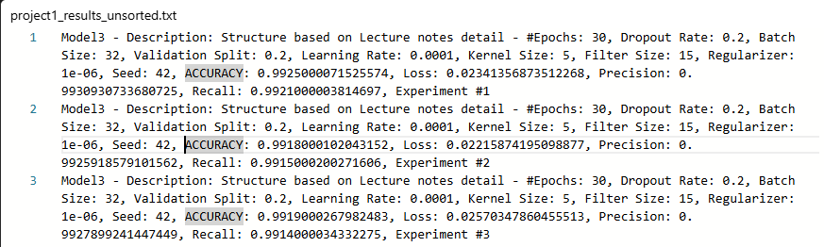
Fig 6 Shows test accuracy(ACCURACY) and training accuracy
<THIS IMAGE NEEDS TO BE REPLACE WITH ONE WITH TRAINING ACURACY INCLUDED ON EACH LINE)
The overall performance of Model 3 is very good and is reliable as it has produced very similar results with 3 runs. However when you look at the diagram in Fig 7, it can be seen that overfitting has occurred.

Accuracy - Overfitting Discussion
Overfitting happens when a model learns the training data and its peculiarities too well. It achieves near perfect accuracy on the training data but performs less favourably on the test data. A model that overfits fails to generalise to new data.
When the graphs(see Fig 7) for the training and validation accuracy for each of the sequential models are viewed over 3 runs, it can be seen that model 3 has been over fitted. From the graph the over fitting appears to happen at around epoch 16 This is the epoch where the training accuracy continues to increase but the validation accuracy appears stationary. An alternative way to see overfitting is to plot the loss against each epoch.
On model 1 and 2 the training and validation graph align on epoch 30 and don't have overfitting.

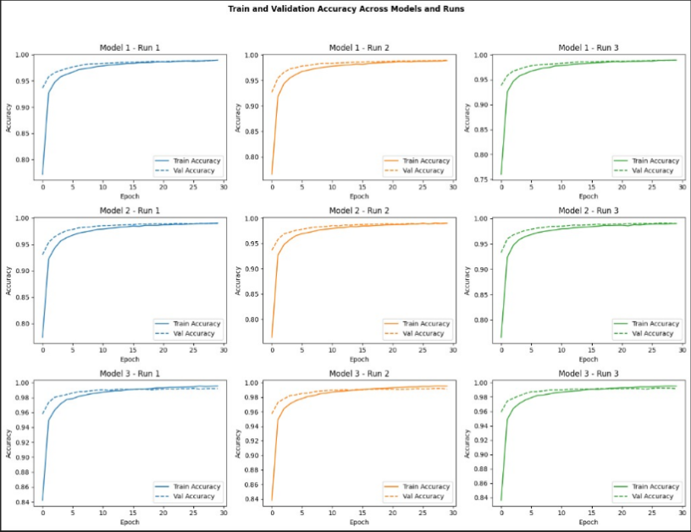
Fig 7 Shows for each of the sequential models, the Training and Validation accuracy scores for 3 runs

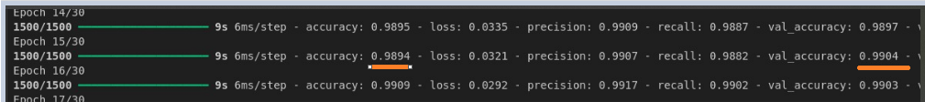
Fig 8 Shows at Epoch 16 the validation and testing accuracy scores

Deliverables
The items delivered for this assignment includes this pdf report and a python script called project1.py This python script will run directly from the Python command line. A Python note book called exploration_X.ipynb is also available if requested.

Lessons learned and changes for future Projects
Given the time constraints we knew it was important to meet early to disciss and agree the scope of the project work. This worked out well as it gave us a good plan to refer to for the weeks that followed. We were fortunate to have a good cross section of skills across the team. This included having good organisational , coding, documention, research and soft skills. We also set up a one drive share point folder which allowed us to work productive together and share documents.
When changes were required for making the project better, team members contibuted their input to improve it. Teams meetings were held face to face either with the whole group during the initial stages of the project and later on in smaller group where individuals needed to work together to complete a work item (Report document or piece of code). We also used Whatapp conference calls to meet remotely when it was not possible to meet face to face. Overall, the project team work well together and used modern communication technology to facilitate the delivery of this project.
One enhacement we would make to this project is to attempt to get the EarlyStopping functionality to behave as expected. In this implementation, we found that it stopped after the third epoch. However when EarlyStopping was removed the model achieve over 99% test accuracy. The value of the EarlyStop that was used is
EarlyStop(monitor='val_loss', patience=6)

Conclusion
The sequential CNN model with 2 Conv2D and 2 Dropout layers achieved a test accuracy in excess of 99%. care need to be taken to ensure that overfitting does not occur when trying to maximise test accuracy as it will then fai to generalise.

References
[1] https://en.m.wikipedia.org/wiki/MNIST_database
[2] https://keras.io/api/layers/convolution_layers/convolution2d/

Appendix A
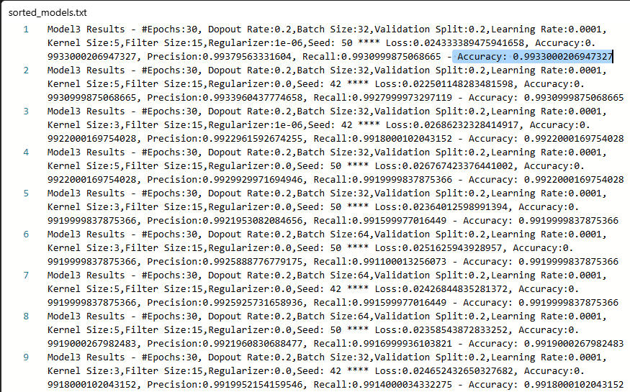

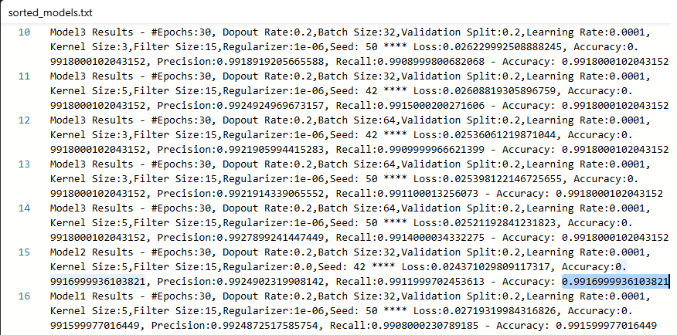

Slides 30 and 32 051-keras-intro-24.4u.pdf
Slide 32, recommending the use of 2 Conv2D/MaxPooling2D layer series for improved restults, 051-keras-intro-24.4up.pdf
Inspiration from Slide 28, 051-keras-intro-24.4up.pdf
Similar to how it is shown on slide 11, 051-keras-intro-24.4up.pdf
As described on slide 24, 05-keras-intro-24.4up.pdf
Slide 31, 0k-keras-intro-24.4up.pdf
ReLU as shown on slide 29
Slide 29, 051-keras-intro-24.4up.pdf
Quote from Slide 31, 051-keras-intro-24.4up.pdf
Slide 31, 051-keras-intro-24.4up.pdf

